

**Efficient Doctor Patient Management Portal**

High Level Design & Low Level Design

**Document Control :**

|  |  |  |  |  |  |  |  |  |
| --- | --- | --- | --- | --- | --- | --- | --- | --- |
| **Efficient Doctor Patient Management Portal** | | | | | | | | |
| Guided by-  **Mr. Sankar** |  |  | |  |  |  |  |  |
| **Date** | **Version** | **Author** | **Brief Description of Changes** | | | | **Approver Signature** | |
| December 07 2022 | 1.0 | B. Navya Sree  P. Gopika  P. Lasya  N. Harshitha  G. Sireesha |  | | | |  | |

**INDEX**

1. Introduction ------------------------------------------------ 4

1.1 Intended audience ------------------------------------------------ 4

1.2 Project purpose ------------------------------------------------ 4

1.3 Key project objective ------------------------------------------------ 4

1.4 Project scope ------------------------------------------------ 4

2. Design overview ------------------------------------------------ 4

2.1 Design objectives ------------------------------------------------ 8

2.2 Error Detection / Exceptional Handling -------------------------------------------- 8

2.3 Performance ------------------------------------------------ 8

2.4 Maintenance ------------------------------------------------8

3. System architecture ------------------------------------------------ 9

3.1 Doctor -----------------------------------------------9

3.2 Patient -----------------------------------------------9

3.3 Admin -----------------------------------------------10

3.3.1 Doctor Record maintenance ----------------------------------------------10

3.3.2 Patient Record Maintenance ----------------------------------------------10

3.4 File Handling -----------------------------------------------10

3.4.1 Doctor Data -----------------------------------------------10

3.4.2 Patient Data ---------------------------------------------11

4. Detailed system design -----------------------------------------------12

4.1 Flowchart of main application ----------------------------------------------12

4.2 DFD Level 0 Diagram ------------------------------------------------13

4.4 DFD Level 1 Diagram ----------------------------------------------13

5. Testing

5.1 Unit Testing ----------------------------------------------16

5.2 Integration Testing —-------------------------------------------17

6. Environmental Description -----------------------------------------------18

1: Introduction

**1.1 Purpose**

The Doctor Appointment Management System is based on the concept of making patient appointments easier. The system helps to reduce the problems that occur when using a manual system and helps patients to skip endless queries. Some hospitals provide the opportunity to make appointments by placing the call, but sometimes these calls are left unattended. The proposed system will overcome all these drawbacks of the existing system. The proposed system has many advantages in that it stores all the information regarding patients' details, patient profiles, prescriptions, etc .

**1.2 Scope**

This project provides a scope of comprehensive overview of the Efficient doctor patient management portal. It highlights the high level flow / use cases in appointment management system and serves as an input to the low level design documents that would further elaborate on the proposed system design.

**1.3 Definitions**

N.A

**1.4 Overview**

The project in whole gives a brief overview of the Appointment management , where the patient and the doctors have to get themselves logged in into the system. where the patient having a specific disease gets the appointment fixed with the doctor having qualification on that disease .

**2. Intended Audience:**

This document is intended to be read by, Doctor, Patient and admin.

**2.1 Project Purpose:**

Efficient doctor patient management portal is based on the concept of making patient appointments easier. The system helps to reduce the problems that occur when using a manual system and helps patients to skip endless queries. Some hospitals provide the opportunity to make appointments by placing the call, but sometimes these calls are left unattended. The proposed system will overcome all these drawbacks of the existing system. The proposed system has many advantages in that it stores all the information regarding patients' details, patient profiles, prescriptions, etc .

.

**2.2 Key Project Objectives:**

1. Allows Doctor patient and admin to register.
2. Patient to book appointmnet.
3. Doctor can view and update the patient history.
4. File Maintenance by admin.
5. Admin can modify the data.

**2.3 Project Scope:**

## This project provides a scope of comprehensive overview of the Efficient doctor patient management portal. It highlights the high level flow / use cases in appointment management system and serves as an input to the low level design documents that would further elaborate on the proposed system design

**3. Design Overview:**

Efficient doctor patient management portal comprises of the following modules:

|  |  |
| --- | --- |
| Name of the module | Doctor Registration |
| Handled by | Bharapaneedi Navya Sree |
|  |  |
| Description | This feature allows the doctor to register in the portal. |

|  |  |
| --- | --- |
| Name of the Module | Doctor edit |
| Handled by | Bharapaneedi Navya Sree |
| Description | This feature allows the doctor to edit basic details. |

|  |  |
| --- | --- |
| Name of the Module | Doctor View |
| Handled by | Bharapaneedi Navya Sree |
| Description | This feature displays basic details of doctor. |

|  |  |
| --- | --- |
| Name of the Module | Doctor Login |
| Handled by | P.Gopika |
| Description | This feature allows the doctor to login into the portal. |

|  |  |
| --- | --- |
| Name of the Module | Patient registration |
| Handled by | Pandeti Lasya |
| Description | This feature allows the patient register in the portal. |

|  |  |
| --- | --- |
| Name of the Module | Patient Login |
| Handled by | P.Gopika |
| Description | This feature allows the Patient to login into the portal. |

|  |  |
| --- | --- |
| Name of the Module | Doctor Slot selection |
| Handled by | P. Lasya |
| Description | This feature doctor to select slot that he is available. |

|  |  |
| --- | --- |
| Name of the Module | Doctor list view |
| Handled by | G. Sireesha |
| Description | This feature displays the list of available doctors with specialization |

|  |  |
| --- | --- |
| Name of the Module | Slot selection |
| Handled by | G. Sireesha |
| Description | This feature allows patient to select in which slot he wants to visit the doctor. |

|  |  |
| --- | --- |
| Name of the Module | Docto Edit |
| Handled by | G. Sireesha |
| Description | This feature allows doctor to edit his basic details like name, mobile no,age. |

|  |  |
| --- | --- |
| Name of the Module | Patient Edit |
| Handled by | P. Lasya |
| Description | This feature allows doctor to edit patients medical information |

|  |  |
| --- | --- |
| Name of the Module | Patient View |
| Handled by | P. Gopika |
| Description | This feature displays the patient list to doctor |

|  |  |
| --- | --- |
| Name of the Module | Doctor Add |
| Handled by | B. Navya Sree |
| Description | This feature adds the new doctor record with details like mci licence id, age, name, gender, mobile number and password |

|  |  |
| --- | --- |
| Name of the Module | Doctor Edit |
| Handled by | P.Gopika |
| Description | This feature allows admin to edit the doctor details. |

|  |  |
| --- | --- |
| Name of the Module | Doctor Delete |
| Handled by | P. Lasya |
| Description | This feature allows admin to delete doctor data from the portal |

|  |  |
| --- | --- |
| Name of the Module | Patient edit |
| Handled by | G. Sireesha |
| Description | This feature allows admin to edit or delete the patient details |

|  |  |
| --- | --- |
| Name of the Module | Admin Login |
| Handled by | N.Harshitha |
| Description | This feature allows admin to login into the portal to see doctor and patient information |

|  |  |
| --- | --- |
| Name of the Module | Doctor List |
| Handled by | N. Harshitha |
| Description | This feature will give a report on the number  Of doctors available in the portal so the admin can edit the details- of the doctor |

|  |  |
| --- | --- |
| Name of the Module | Doctor file to list |
| Handled by | N. Harshitha |
| Description | This feature allows to write Doctor records to the list. |

|  |  |
| --- | --- |
| Name of the Module | Doctor List to File |
| Handled by | N.Harshitha |
| Description | This feature allows to read Doctor records to the list. |

|  |  |
| --- | --- |
| Name of the Module | Patient File to list |
| Handled by | N. Harshitha |
| Description | This feature allows to write Patient records to the list. |

|  |  |
| --- | --- |
| Name of the Module | Patient List to File |
| Handled by | N. Harshitha |
| Description | This feature allows to read patient records to the  list. |

**3.1 Design Objectives:**

Doctor-patient Management portal communicates among Doctor’s, patients and admin for the supply of left-over food to the needy.

The main design features include four major parts:

- The architecture,

- The user interface design,

- The files,

- Process relation,

- Automation .

**3.2 Error Detection / Exceptional Handling:**

If the Doctor or Patient wants to register with the existed user ID then it displays “User already Exists”. If the patient wants to edit doctor details it displays “Permission Denied”.

**3.3 Performance:**

Performance is going to be very important for this project. For everything to run smoothly for this project, The portal will work on the customer's terminal and the performance depends upon the hardware component of the customer’s portal.

**3.4 Maintenance:**

Very little maintenance should be required for this setup. An initial configuration will be the only portal required interaction after the portal is put together. The only other user maintenance would be any changes to settings after setup, and any specified special cases where user settings or history need to be changed. Physical maintenance on the portal’s parts may be required, and would result in temporary loss of data or Internet. Upgrades of hardware and software should have little effect on this project, but may result in downtime

**4. SYSTEM ARCHITECTURE: -**

**4.1 Doctor:**

**4.1.1 : doctor_registration:** This feature allows to add a new Doctor record. I asks for the Doctor MCI licence id, name of Doctor, Age, gender, weight, Mobile number and password.

**4.1.2 : doctor_slot_selection:** This feature allows the Doctor to select slots that he is available.

**4.1.3doctor_file_maintenance:** This feature displays the details of Doctor.

**4.1.4: view_patient_history :** This feauture allows doctor to view patient medical history

## 4.2 Patient:

**4.2.1 :patient_Registration**: This feature allows to add the new Patient record . It asks for the Aadhar Number , Name, Age, Gender, weight and contact details.

**4.2.2 :patient_login:** This feature allows the Patient to login into the portal

**4.2.3 :book_appointment:** This feature allows patient to book appointment.

## 4.3 Admin:

* **Admin_login:** This feature allows admin to login with id and password
* **Edit_doctor_info:** This feature allows admin to add, modify or delete the doctor details.
* **Edit_patient_info:** This feature allows admin to add or delete patient data.

**4.4 : File Handling:**

**4.4.1 : Doctor File Handling:**

* **Doctor_file_to _list:** This feature allows to write Doctor records to the list.
* **Doctor_list_to_file:** This feature allows to read Doctor records from the list.

**4.4.2 : Patient File Handling:**

* **Patient_file_to_list:** This feature allows to write Patient records to the list.
* **Patient_list_to_file:** This feature allows to read Patient records from the list.

**5. Detailed System Design**

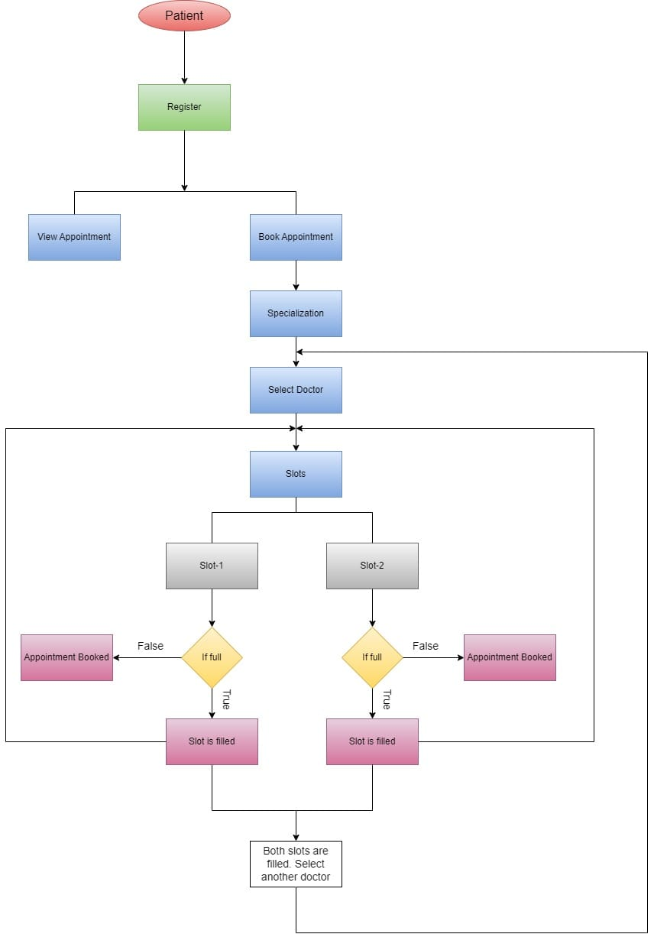

5.1Patient Flow Chart

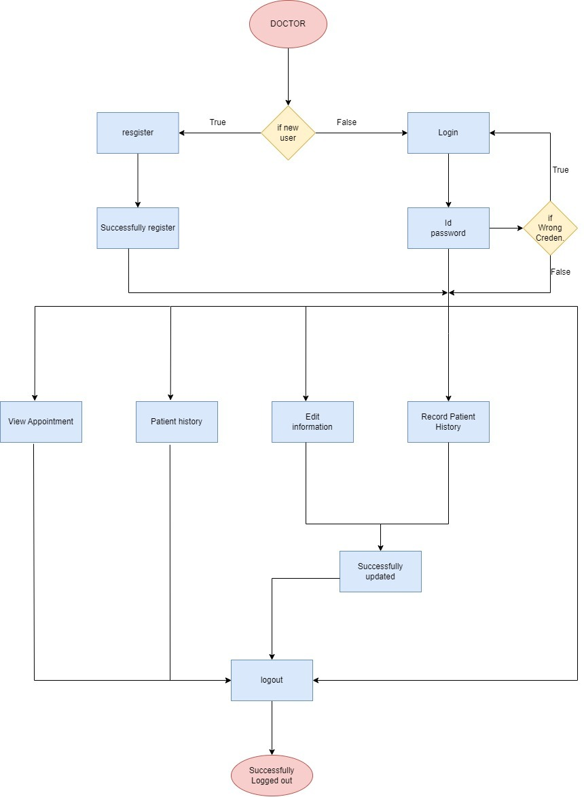

5.2 Doctor flow chart

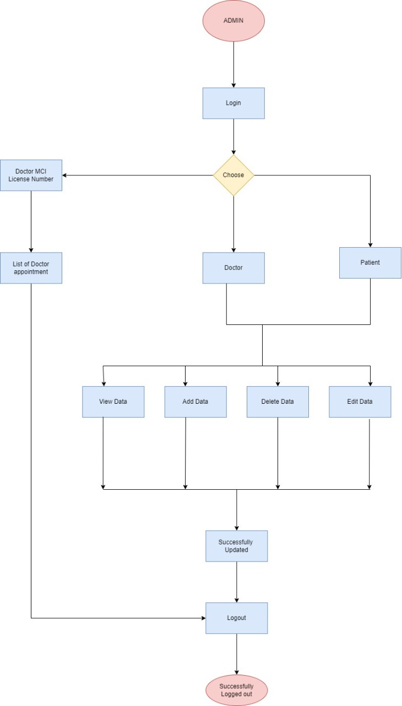

5.3 Admin Flow Chart

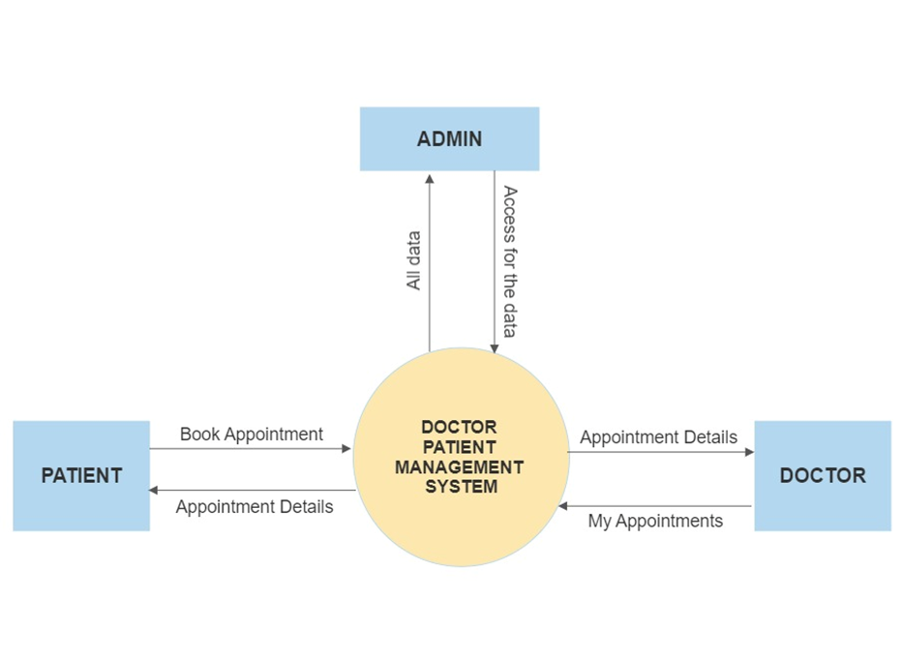

**5.4 DFD LEVEL 0 DIAGRAM**

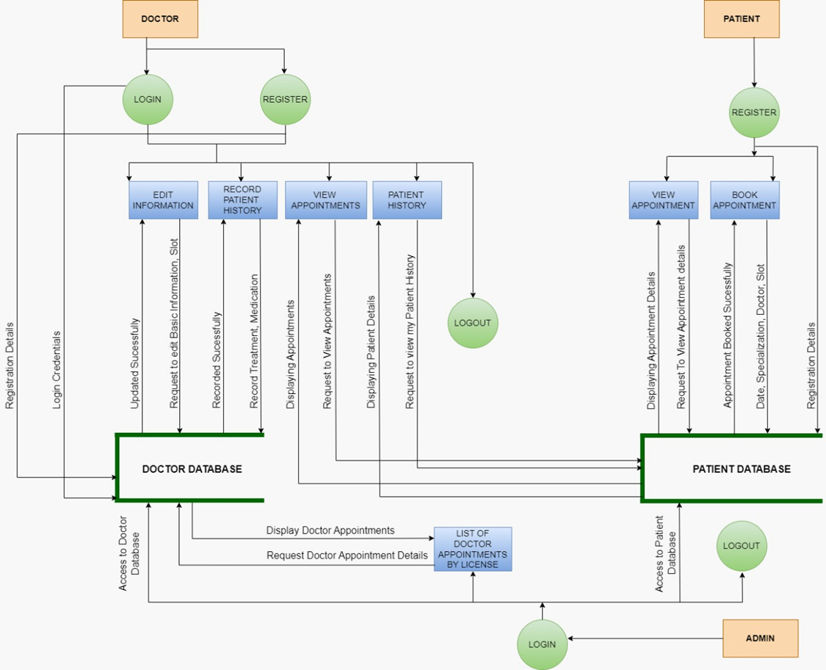

5.5 **DFD LEVEL 1 DIAGRAM**

1. **Testing**

**7.1 : Unit Testing :**

UT_01 : Doctor _Registration:

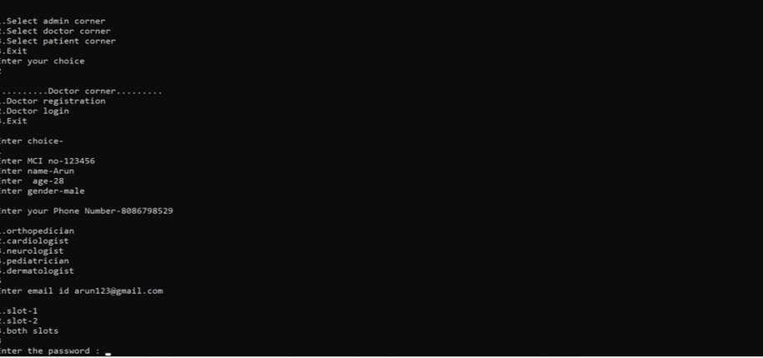

View patient details:

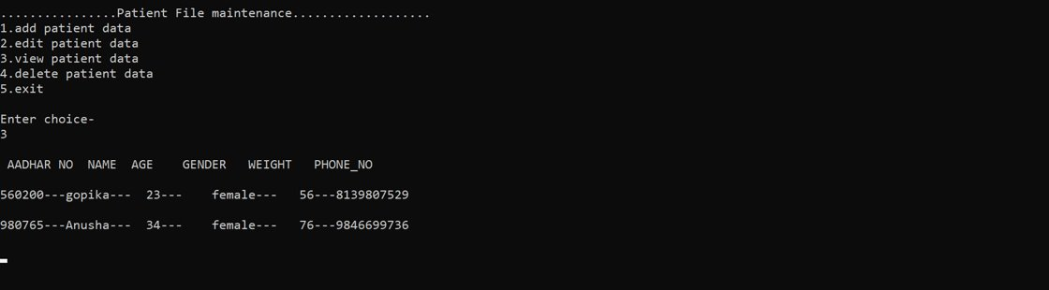

View doctor’s profile:

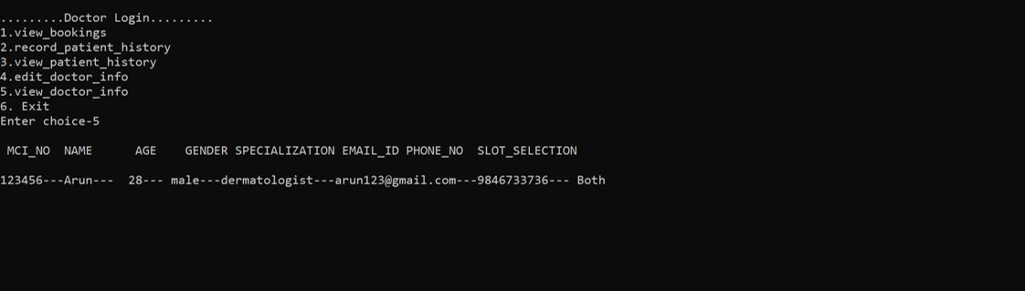

**View doctor’s from admin portal:**

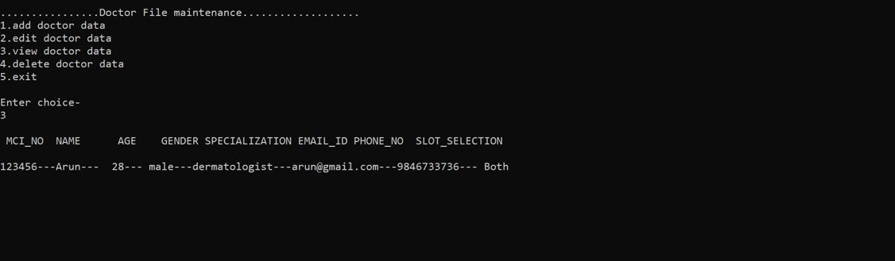

Slot booking:

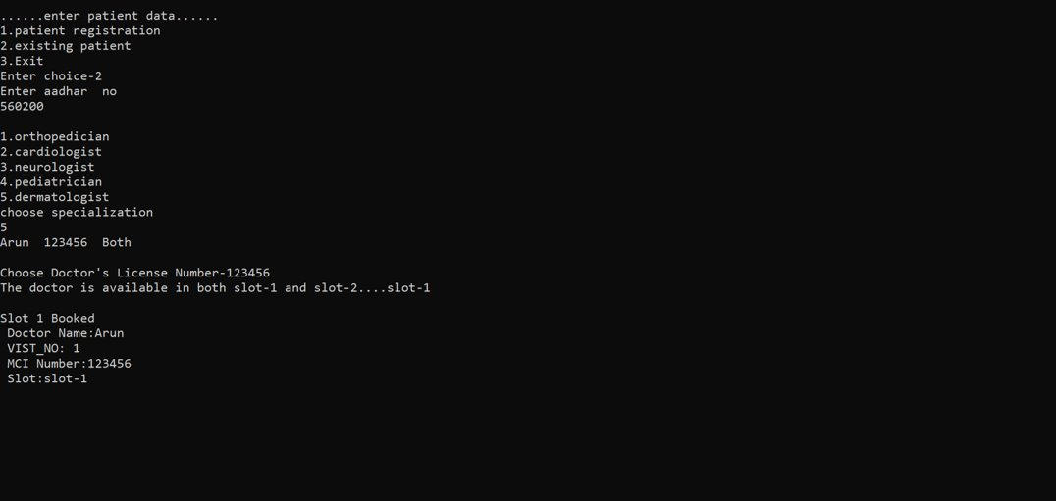

**6.2 : Integrating Testing :**

Record patient medical history:

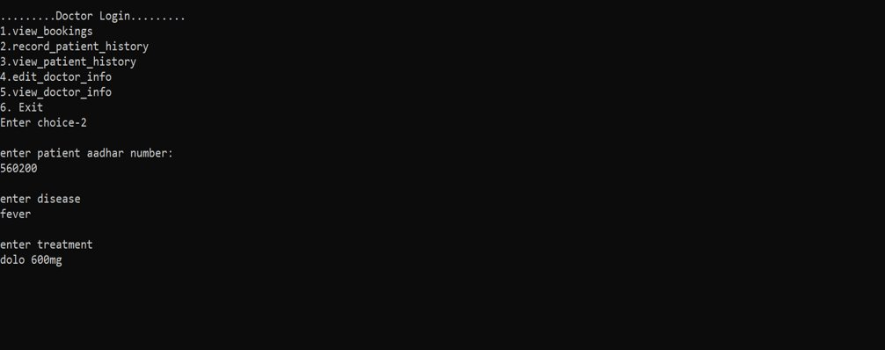

Patient _registration:

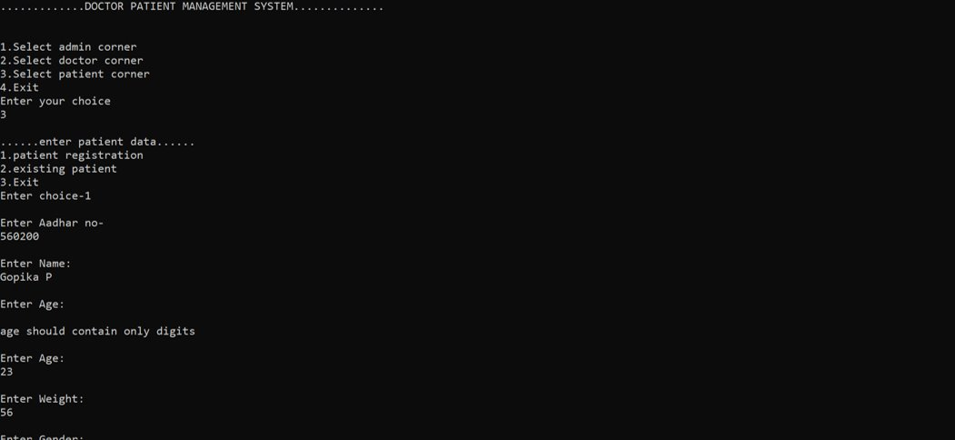

Main _ menu:

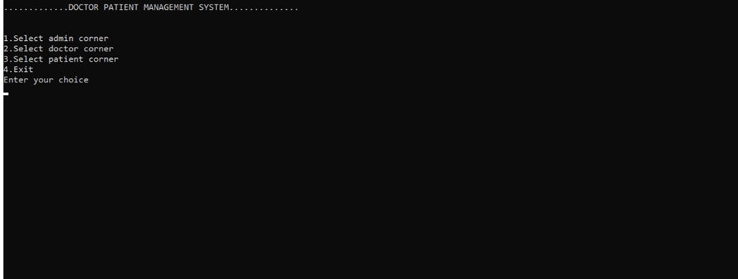

Admin portal:

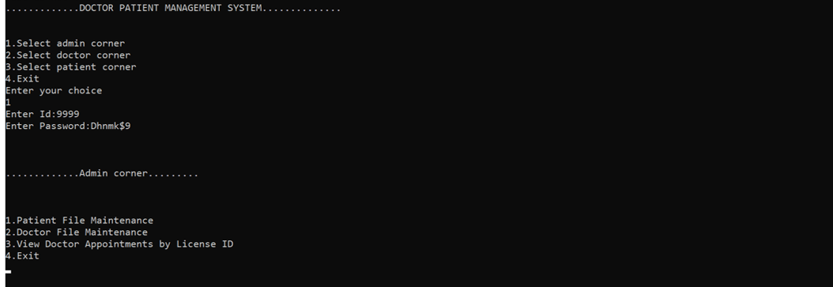

**7.Environment Description:**

**7.1 Time Zone Support:** IST- Kolkata

**7.2 Language Support:** English

**7.3 User Desktop Requirements:**

a. 64-bit processor, 1 GHz or faster

b. At least 2 GB free hard drive space

c. At least 1 GB RAM

**7.4 Server-Side Requirements:**

a. 64-bit processor, 1 GHz or faster

b. At least 1 GB free hard drive space

c. At least 1GB RAM

**7.4.1 Deployment Considerations:**

a. Easy setup: no session storage daemon, use tmpfs and memory

caching to enhance performance.

b. Local storage is used.

c. No network latency to consider.

d. To scale buys a bigger CPU, more memory, larger hard drive, or

additional hardware.

**7.4.2 Application Server Disk Space:**

No such disk space is required as the program is fully functional on

online IDE(s) as well. The Local Operating System is required and

one text file to store the records of processes.

**7.4.3 Database Server Disk Space:**

No such disk space is required as the program is fully functional on

online IDE(s) as well. The Local Operating System is required and

one text file to store the records of processes.

**7.4.4 Integration Requirements:**

1. Language: C

2. Tools: Splint , Valgrind

3. Complier: gcc

4. Linux Environment

**7.4.5 Jobs:**

We can establish connections between clients who are connected to the server. And we can search the chat history of the clients.

**7.4.6 Network:** End to End

**7.5 Configuration:**

**7.5.1: Operating System**: Linux environment